Year 10 |  | Factorisation | Non Calculator
Skills and Knowledge Assessed:  - Factorise algebraic expressions by taking out a common algebraic factor (ACMNA230)  - Apply the four operations to simple algebraic fractions with numerical denominators (ACMNA232)  - Expand binomial products and factorise monic quadratic expressions using a variety of strategies (ACMNA233) |  |  | Name_________________
Section 1 Short Answer Section
Write all working and answers in the spaces provided on this test paper.

Factorise 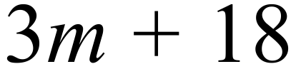.

……………………………………………………………………………………………….
Factorise 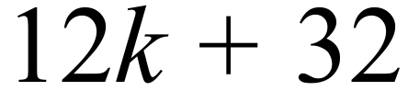.

……………………………………………………………………………………………….
Factorise 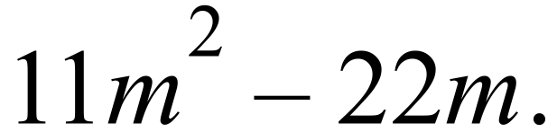

……………………………………………………………………………………………….
Factorise 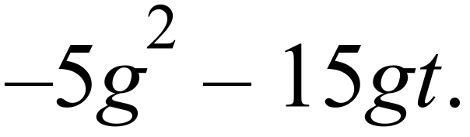

……………………………………………………………………………………………….
Factorise 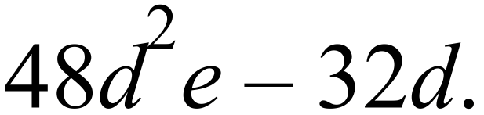

……………………………………………………………………………………………….
Factorise 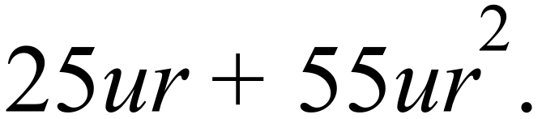

……………………………………………………………………………………………….
Factorise 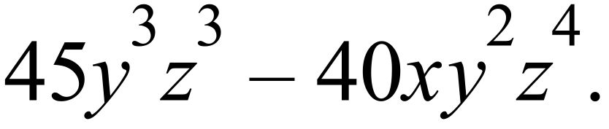

……………………………………………………………………………………………….
Factorise 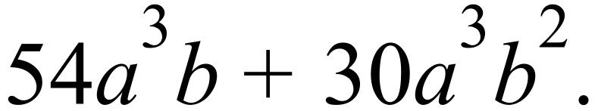

……………………………………………………………………………………………….
Factorise 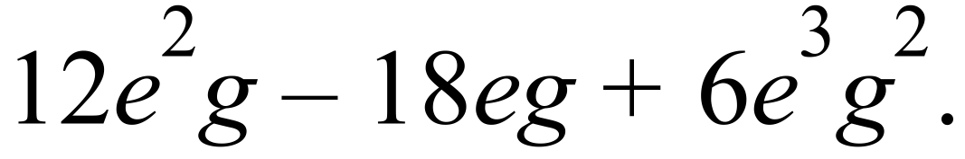

……………………………………………………………………………………………….
Factorise 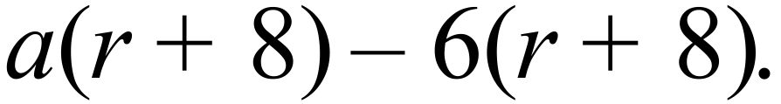

……………………………………………………………………………………………….
Factorise 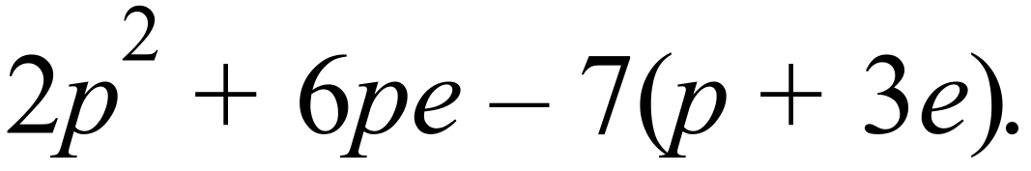

……………………………………………………………………………………………….
Factorise 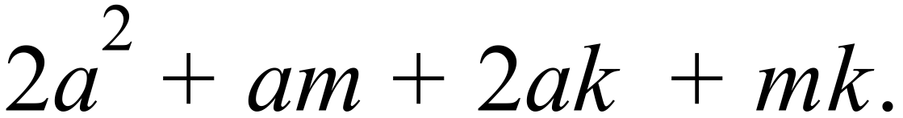

……………………………………………………………………………………………….
Factorise 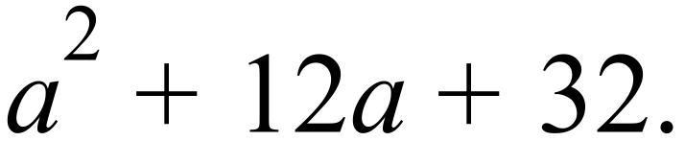

……………………………………………………………………………………………….
Factorise 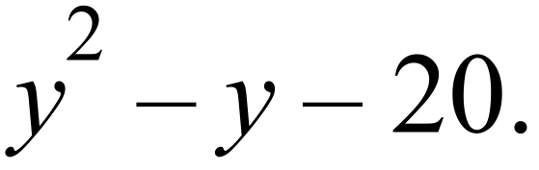

……………………………………………………………………………………………….
Factorise 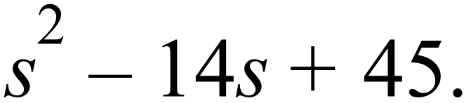

……………………………………………………………………………………………….
Factorise 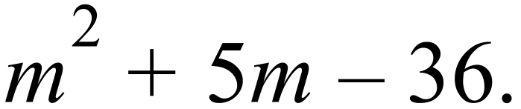

……………………………………………………………………………………………….
Factorise 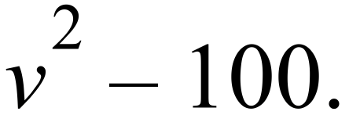

……………………………………………………………………………………………….
Factorise 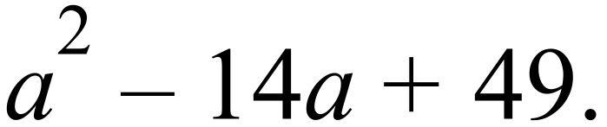

……………………………………………………………………………………………….
Factorise 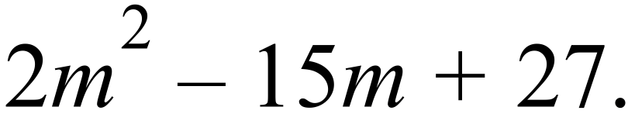

……………………………………………………………………………………………….

……………………………………………………………………………………………….
Factorise 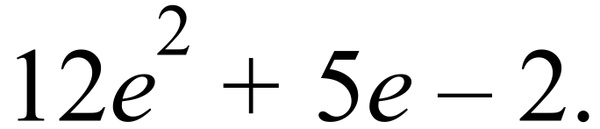

……………………………………………………………………………………………….

……………………………………………………………………………………………….
Factorise 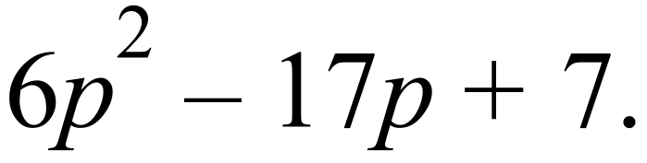

……………………………………………………………………………………………….

……………………………………………………………………………………………….
Factorise 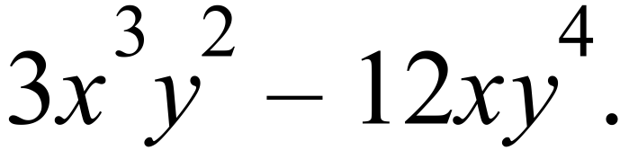

……………………………………………………………………………………………….

……………………………………………………………………………………………….

Year 10 |  | Factorisation | Calculator Allowed
 |  | Factorisation | Name_________________
Section 2 Multiple Choice Section
Mark all your answers on the accompanying multiple choice answer sheet, not on this test paper. You may do any working out on this test paper. Calculators are allowed for this section.

Factorise 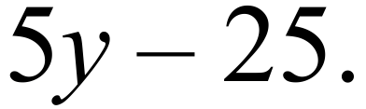

A. 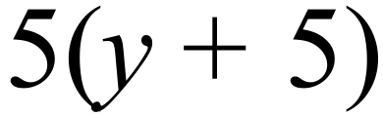 B. 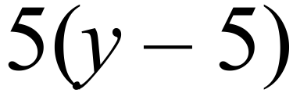 C. 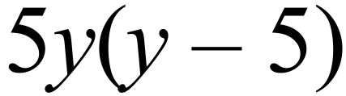 D. 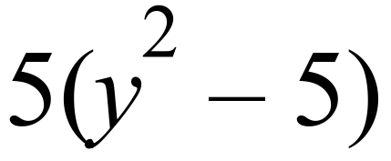
Factorise 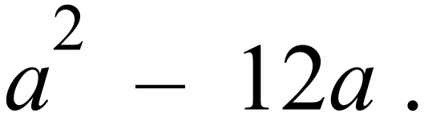

A. 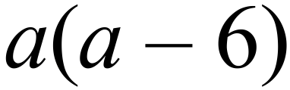 B. 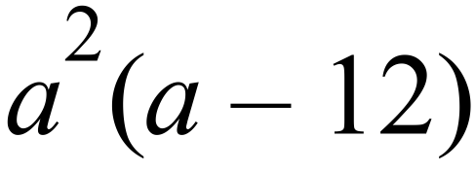 C. 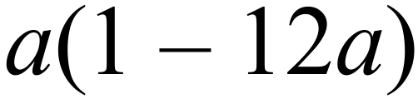 D. 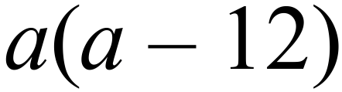
Factorise 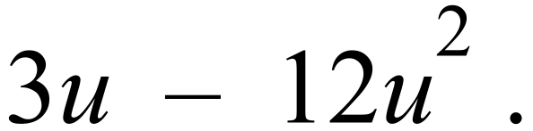

A. 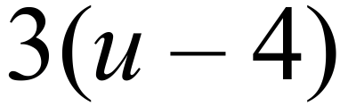 B. 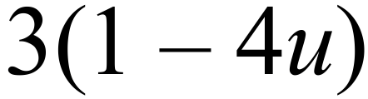 C. 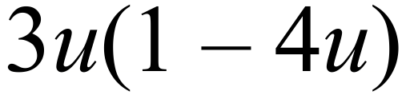 D. 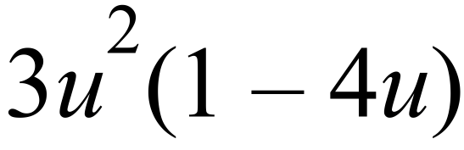
Factorise 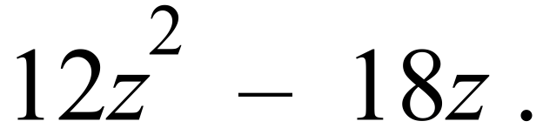

A. 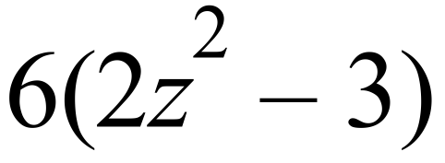 B. 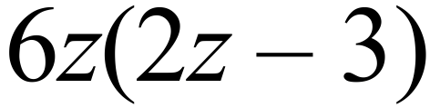 C. 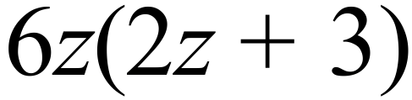 D. 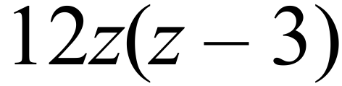
Factorise 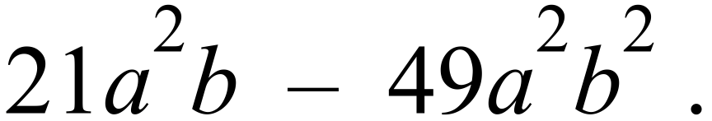

A. 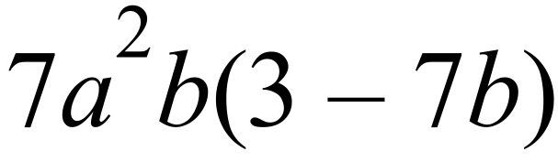 B. 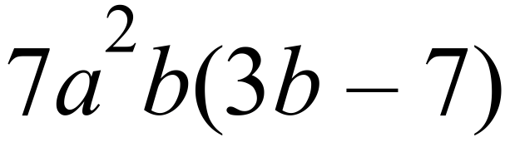
C. 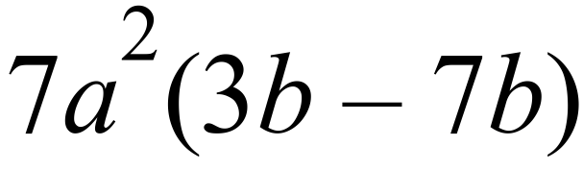 D. 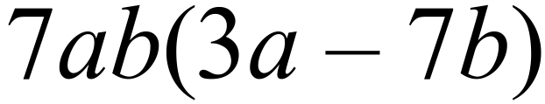
Factorise 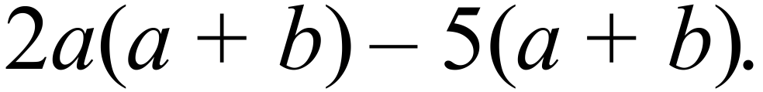

A. 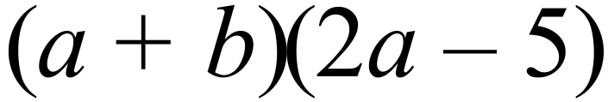 B. 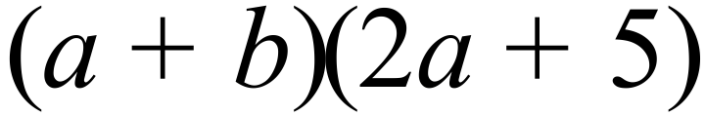
C. 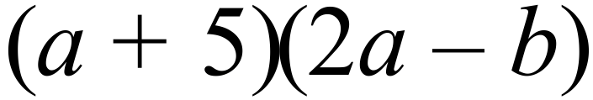 D. 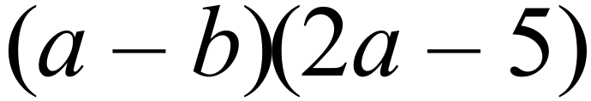
Factorise 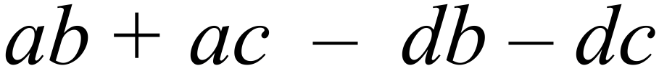

A. 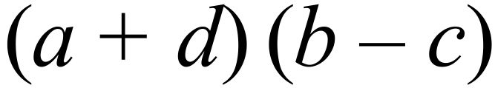 B. 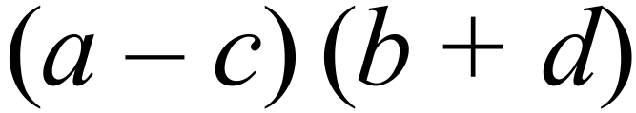
C. 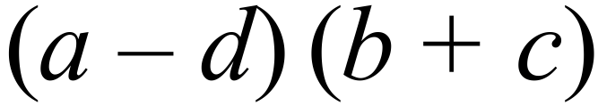 D. 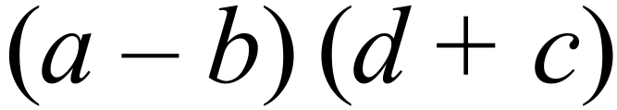
Factorise 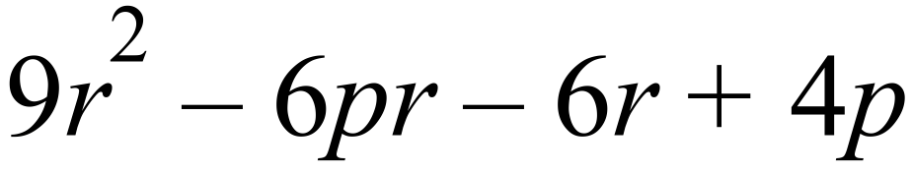

A. 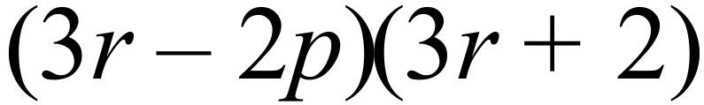 B. 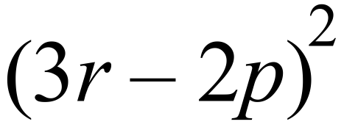
C. 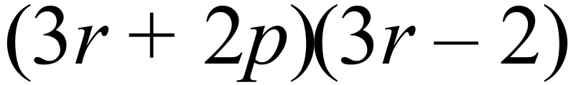 D. 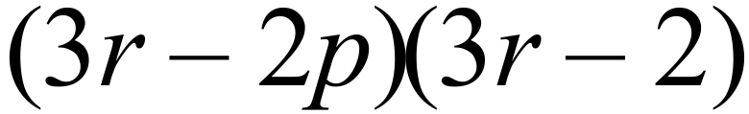
Factorise 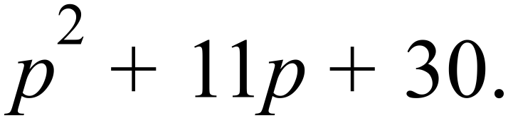

A.  B. 
C. 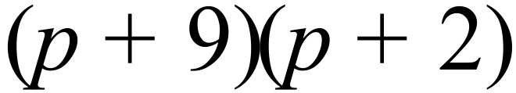 D. 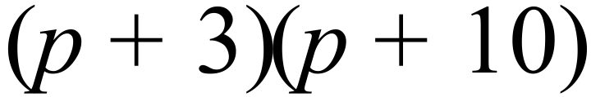
Factorise 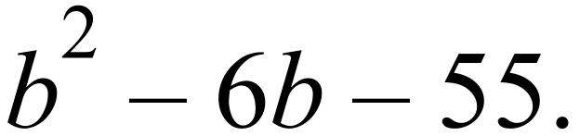

A. 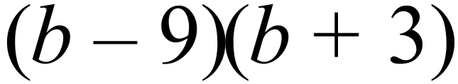 B. 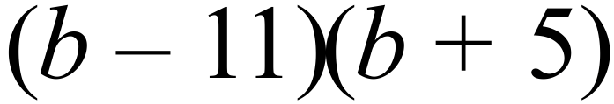
C. 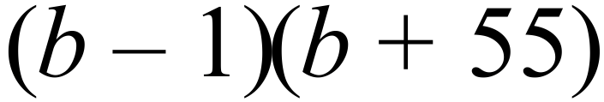 D. 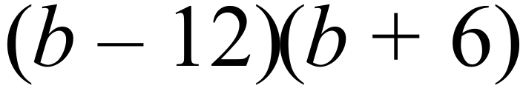
Factorise 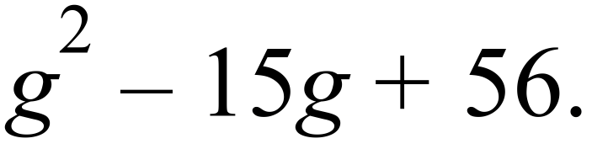

A.  B. 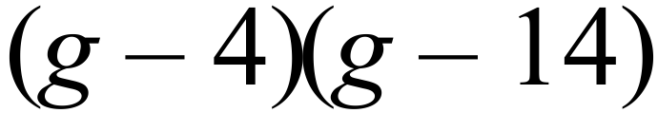
C.  D. 
Factorise 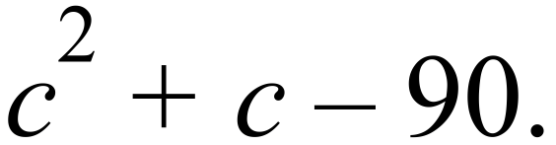

A. 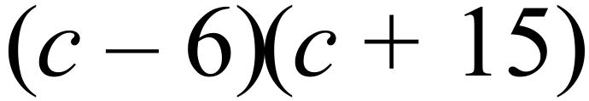 B. 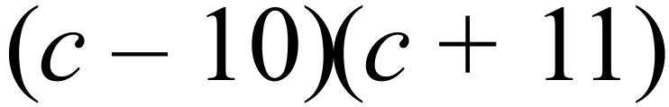
C. 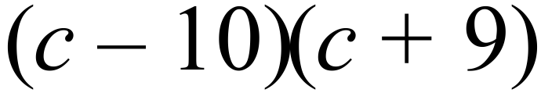 D. 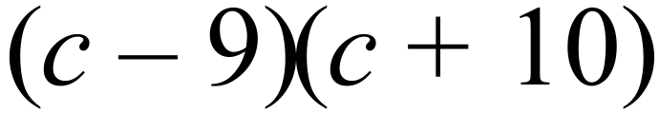
Factorise 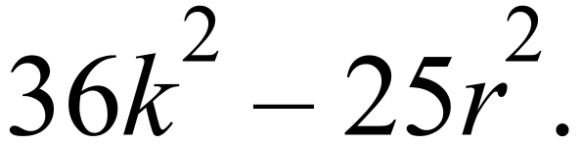

A. 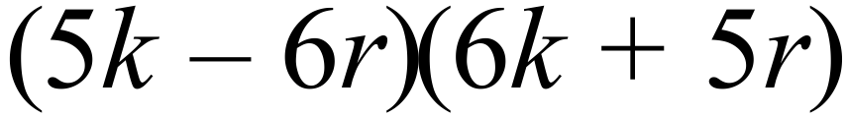 B. 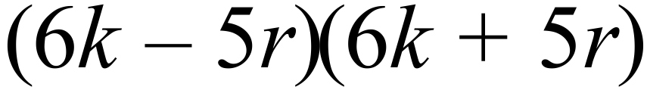
C. 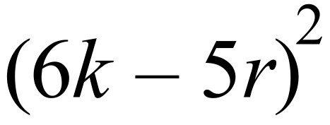 D. 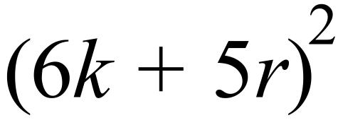
Factorise 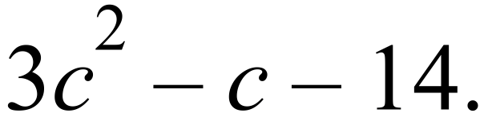

A. 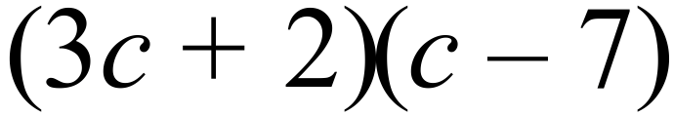 B.
C. 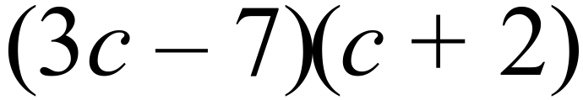 D. 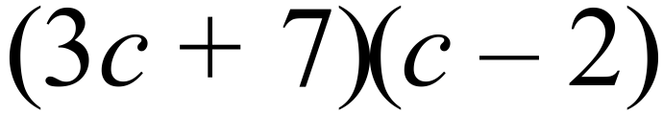
Factorise 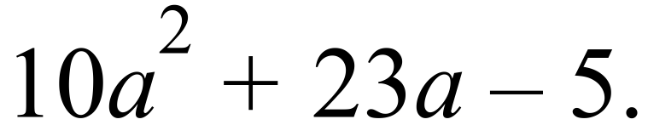

A. 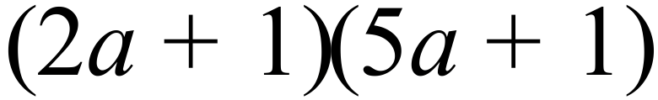 B. 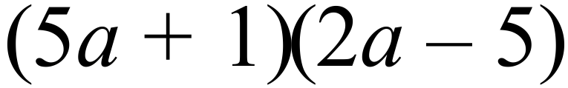
C. 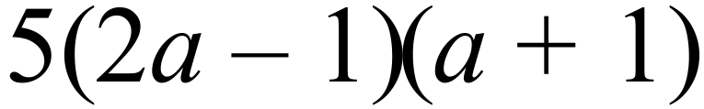 D. 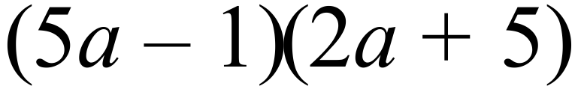
Factorise 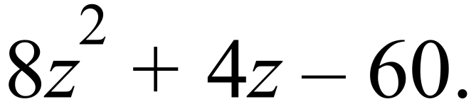

A. 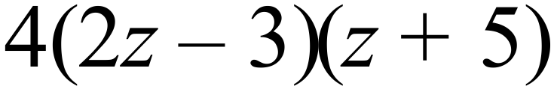 B. 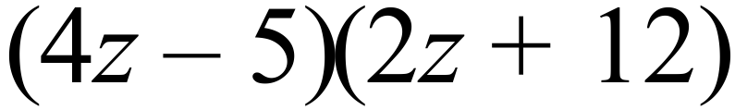
C. 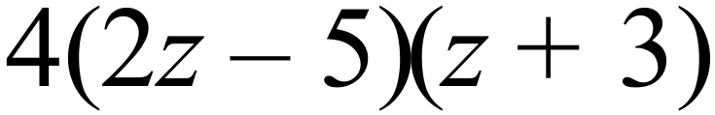 D. 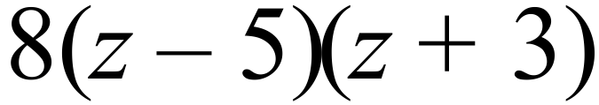

Year 10 | Factorisation | Calculator Allowed
Year 10 | Factorisation | Name___________________
Section 3 Longer Answer Section
Write all working and answers in the spaces provided on this test paper.

 |  | Marks
1. | Simplify the following algebraic fractions, by first factorising.
 | (a) 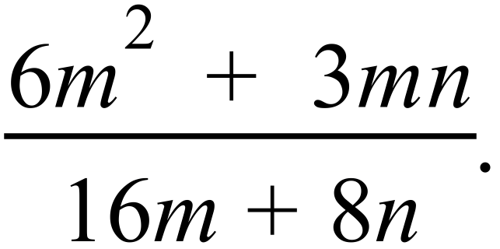  ……………………………………………………………………………………………....  ………………………………………………………………………………………………. | 2
 | (b) 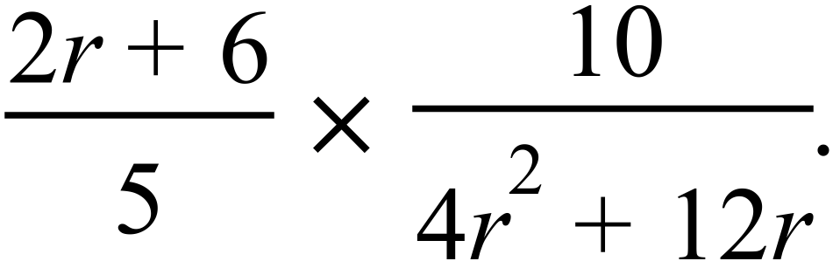  ……………………………………………………………………………………………....  ………………………………………………………………………………………………. | 2

2. | Simplify the following algebraic fractions, by first factorising.
 | (a) 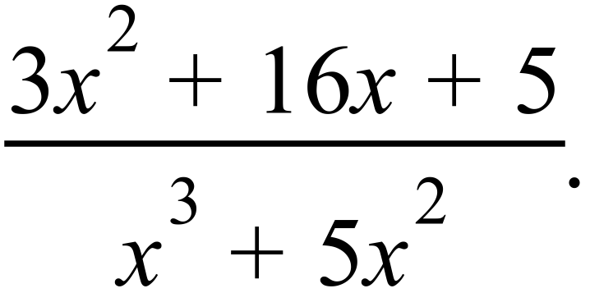  ……………………………………………………………………………………………....  ………………………………………………………………………………………………. | 2
 | (b) 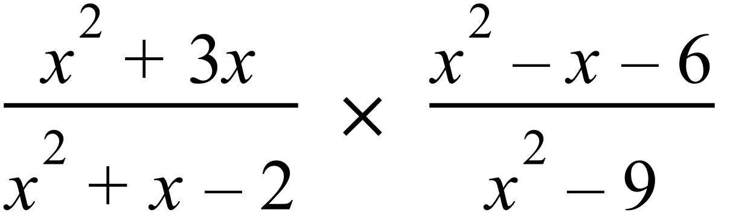  ……………………………………………………………………………………………....  ………………………………………………………………………………………………. | 3
 | (c) 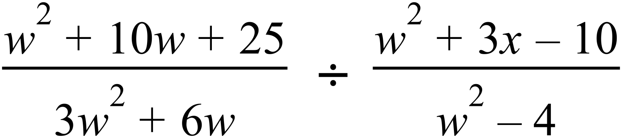  ……………………………………………………………………………………………....  ………………………………………………………………………………………………. | 3

Multiple Choice Answer Sheet
Factorisation
Name _____________________________________________
Completely fill the response oval representing the most correct answer.

1. A B C D
2. A B C D
3. A B C D
4. A B C D
5. A B C D
6. A B C D
7. A B C D
8. A B C D
9. A B C D
10. A B C D
11. A B C D
12. A B C D
13. A B C D
14. A B C D
15. A B C D
16. A B C D
Year 10 |  | Factorisation | Non Calculator
Section 1 Short Answer Section
ANSWERS
No. | WORKING |  | ANSWER
 | 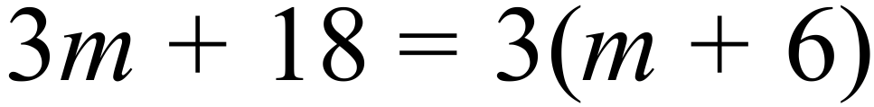 |  | 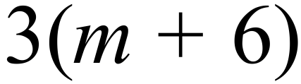
 | 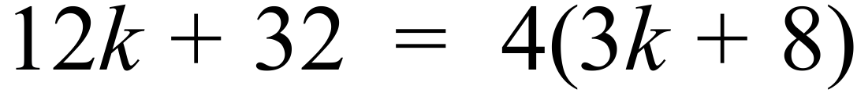 |  | 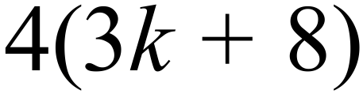
 | 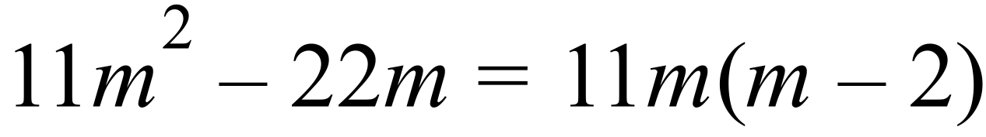 |  | 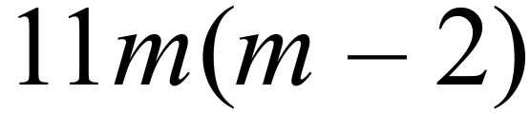
 | 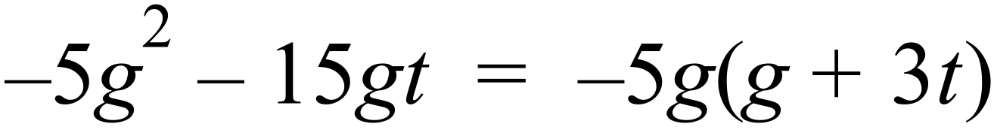 |  | 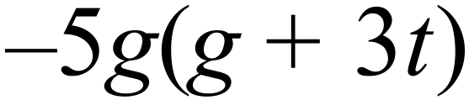
 | 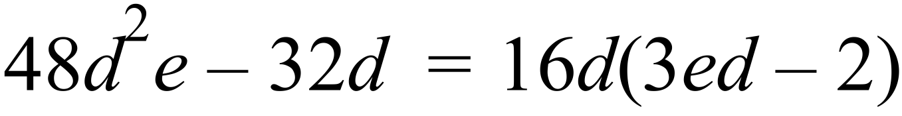 |  | 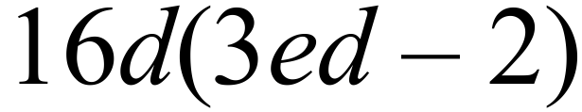
 | 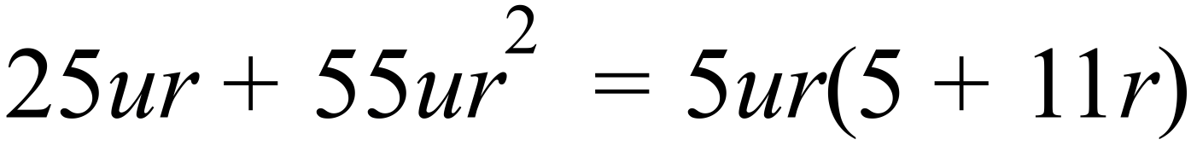 |  | 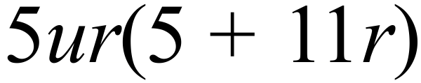
 | 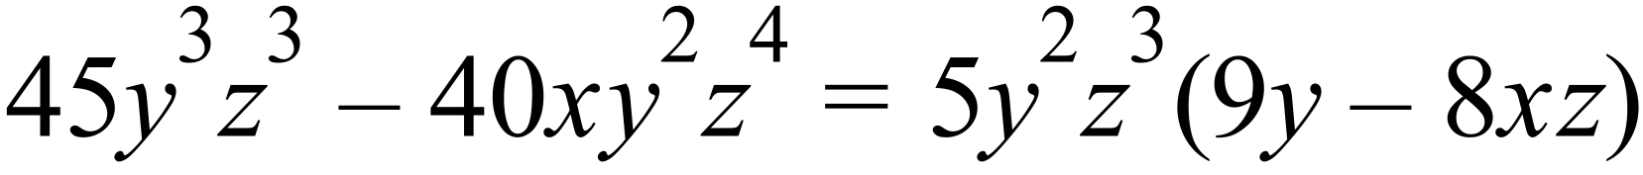 |  | 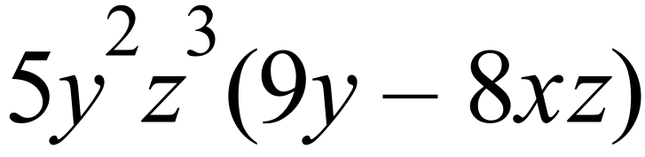
 | 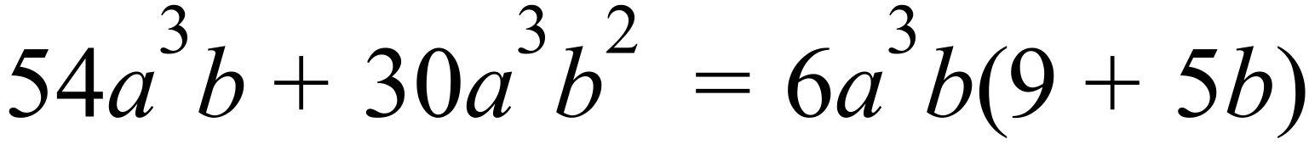 |  | 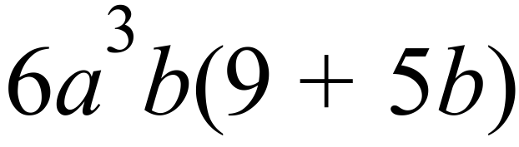
 |  |  | 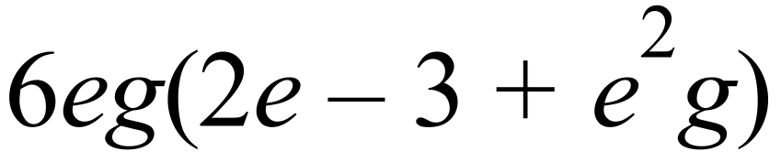
 |  |  | 
 |  |  | 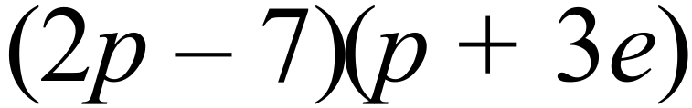
 |  |  | 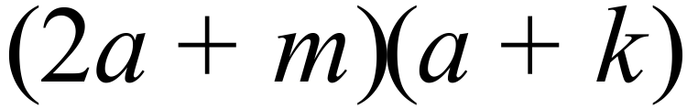
 | 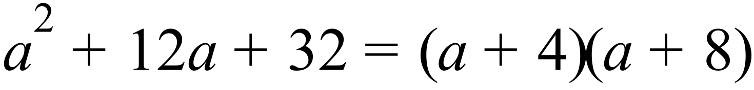 |  | 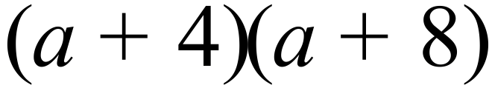
 | 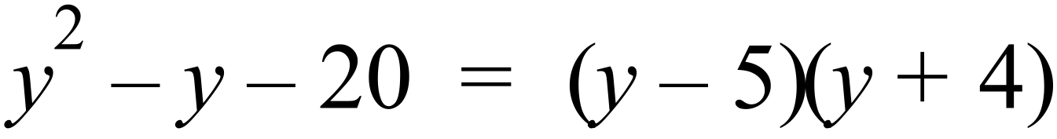 |  | 
 | 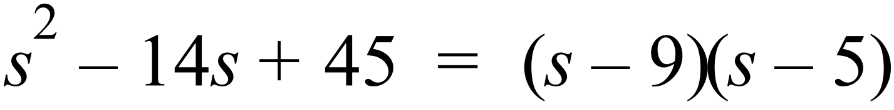 |  | 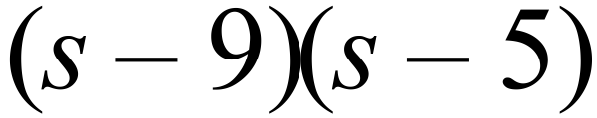
 | 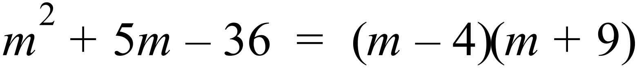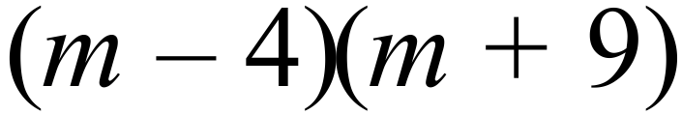
 | 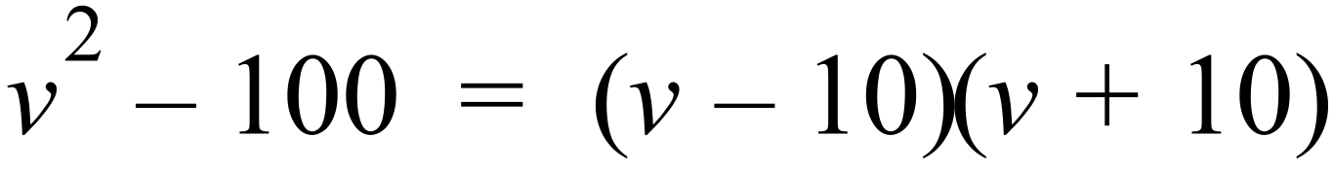 |  | 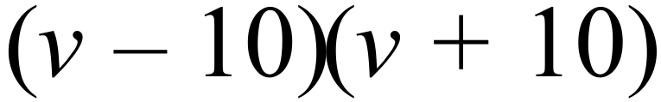
 |  |  | 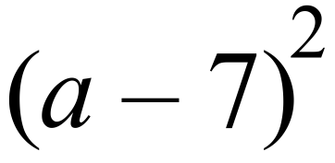
 | 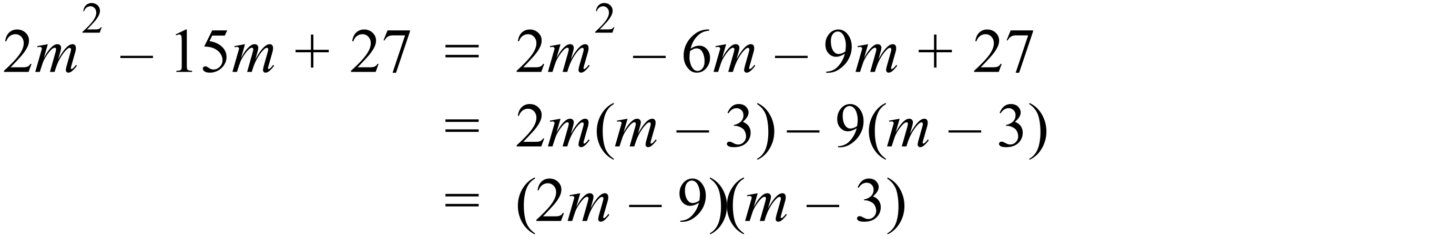 |  | 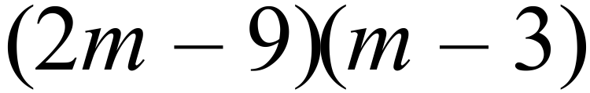
 | 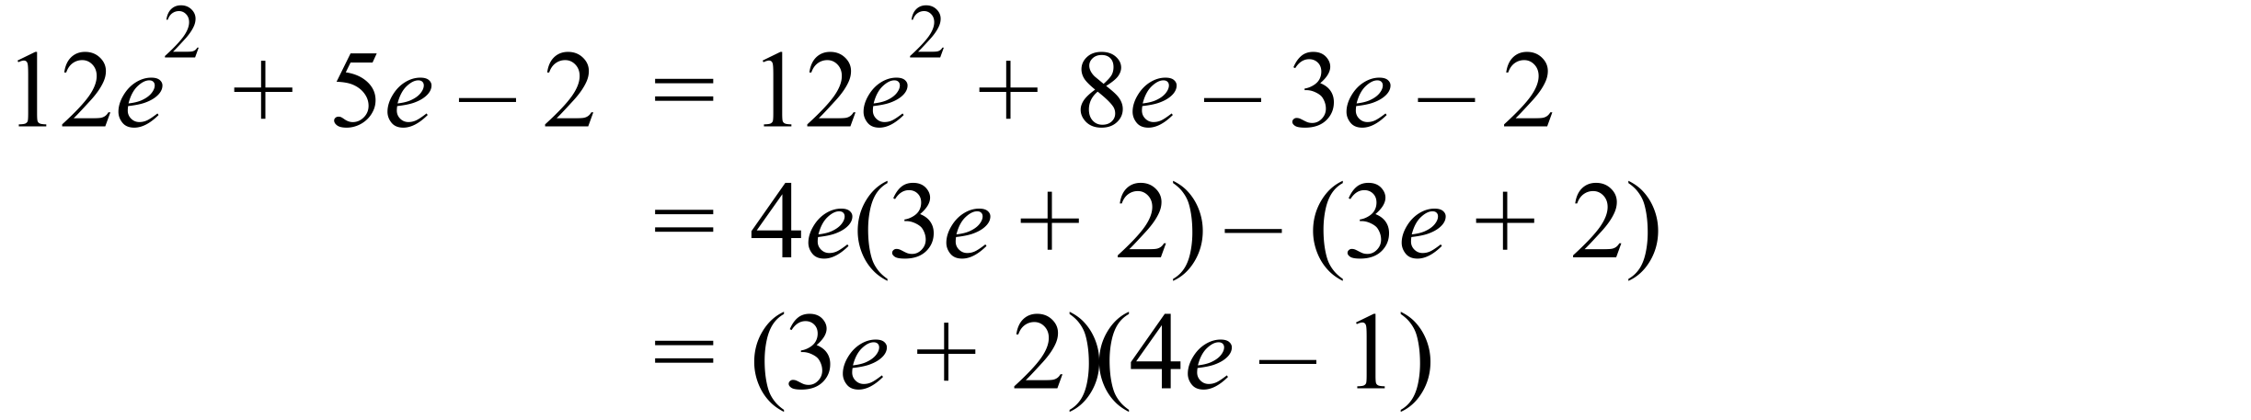 |  | 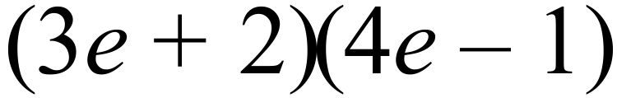
 | 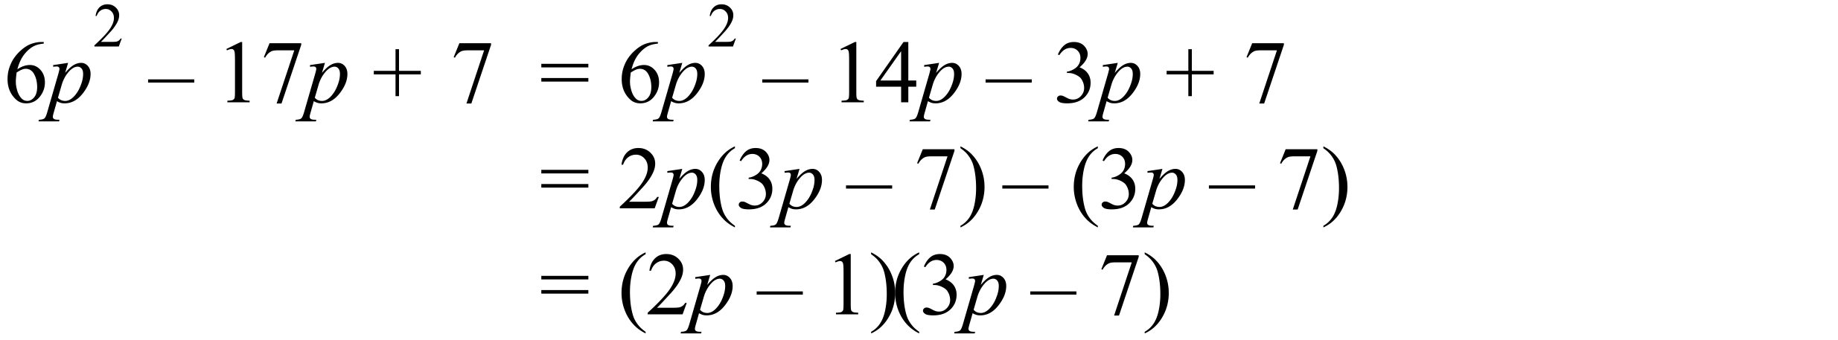 |  | 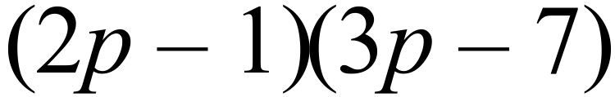
 | 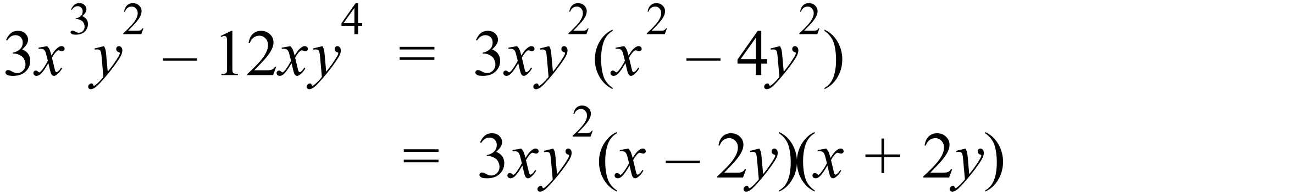 |  | 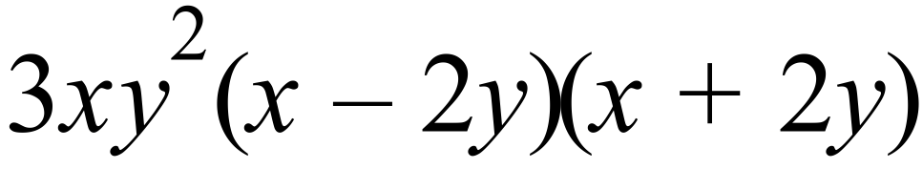

Year 10 |  | Factorisation | Calculator Allowed
Section 2 Multiple Choice Section
ANSWERS
No. | WORKING |  |  | ANSWER
 | 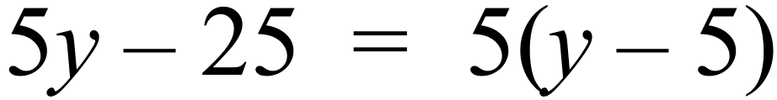 |  |  | B
 | 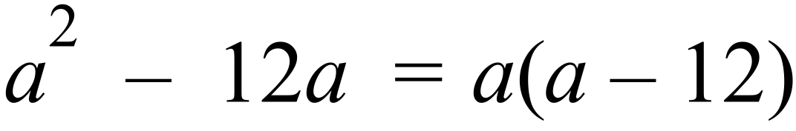 |  |  | D
 | 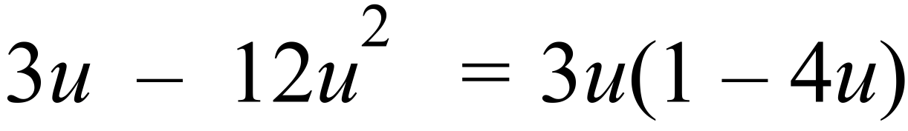 |  |  | C
 | 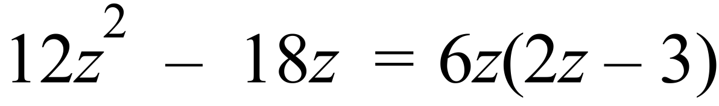 |  |  | B
 | 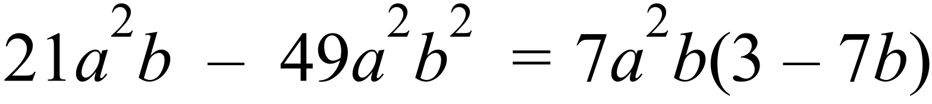 |  |  | A
 |  |  |  | A
 |  |  |  | C
 | 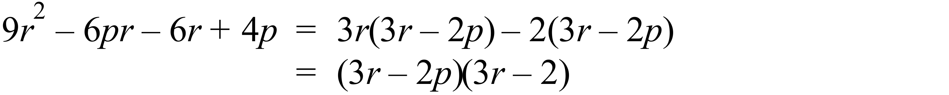 |  |  | D
 | 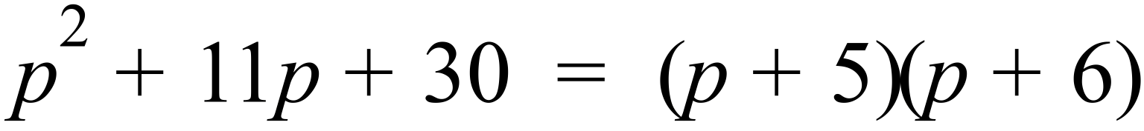 |  |  | A
 | 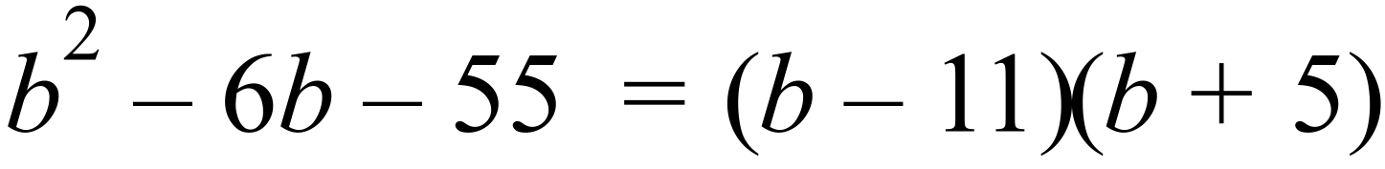 |  |  | B
 | 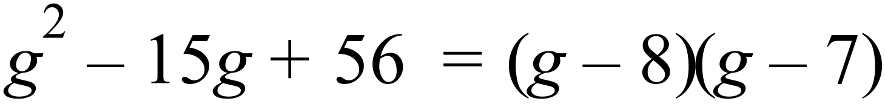 |  |  | A
 | 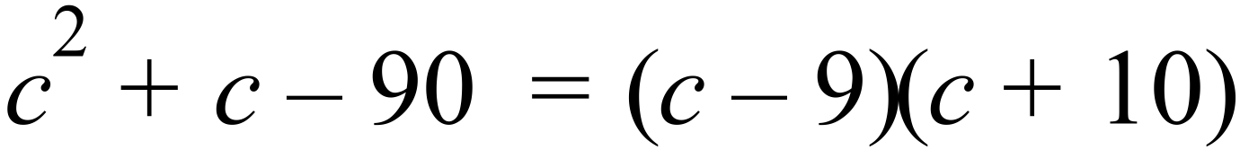 |  |  | D
 | 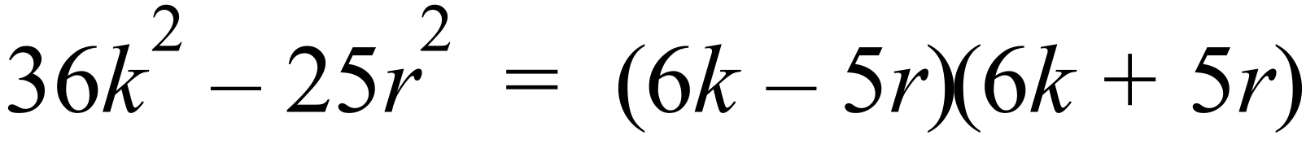 |  |  | B
 | 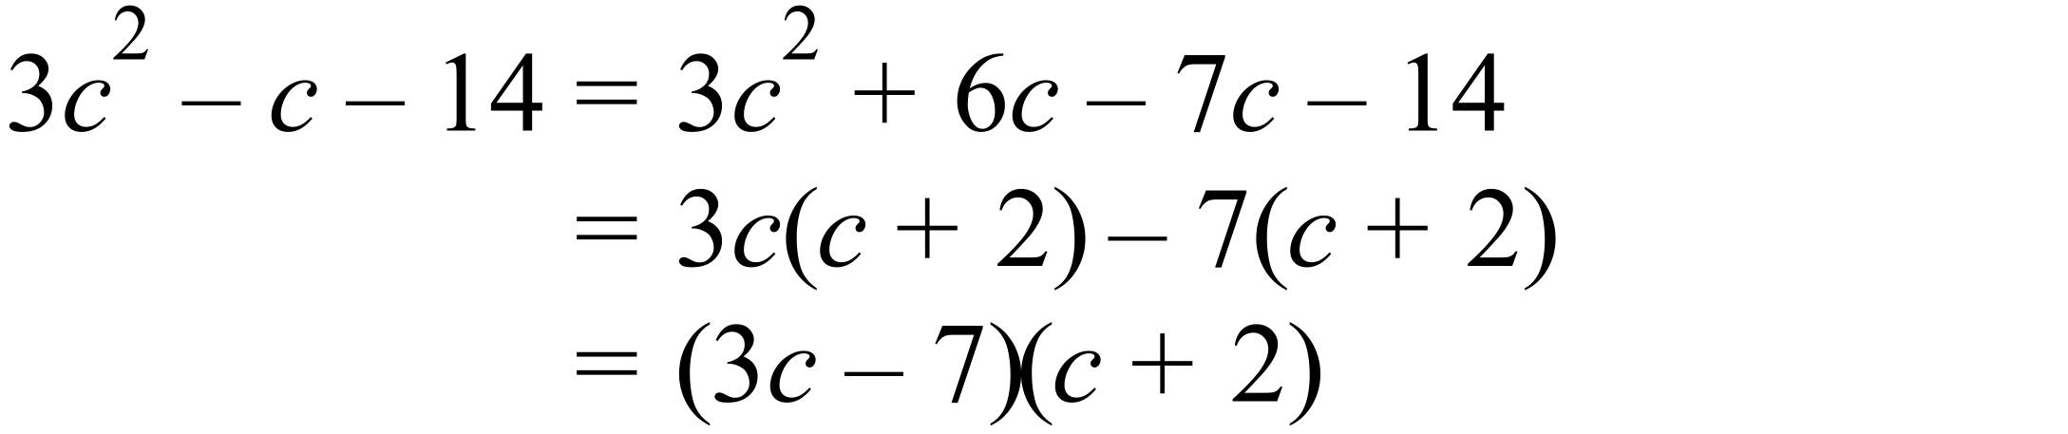 |  |  | C
 | 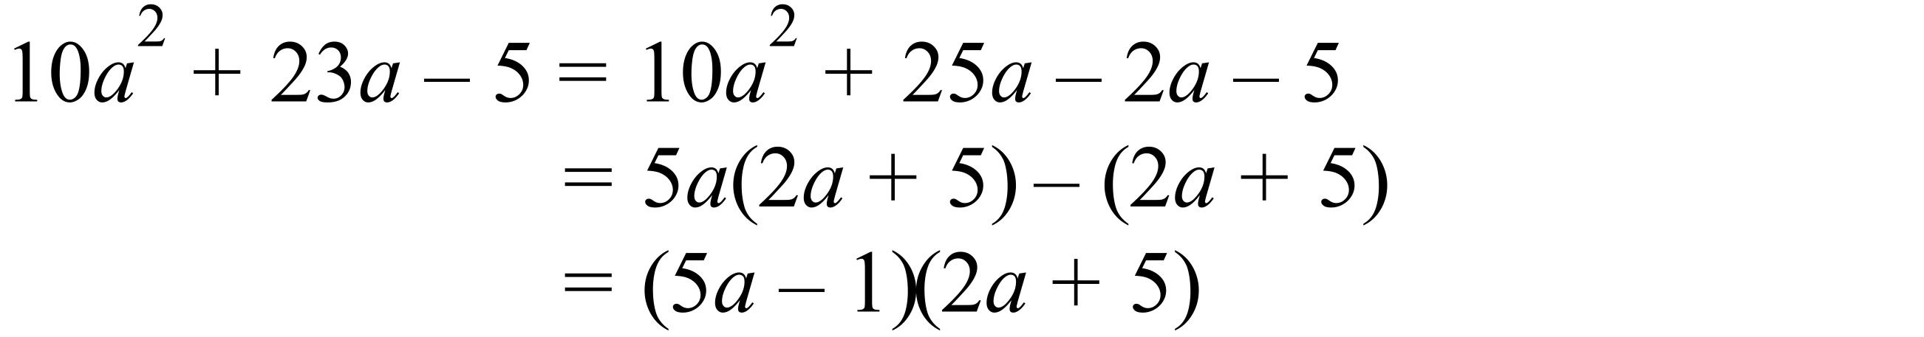 |  |  | D
 | 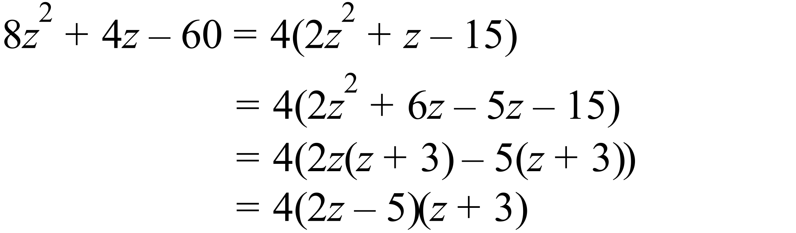 |  |  | C

Multiple Choice Answer Sheet
Factorisation
Name _______ANSWERS_______________________________
Completely fill the response oval representing the most correct answer.

1. A B C D
2. A B C D
3. A B C D
4. A B C D
5. A B C D
6. A B C D
7. A B C D
8. A B C D
9. A B C D
10. A B C D
11. A B C D
12. A B C D
13. A B C D
14. A B C D
15. A B C D
16. A B C D
Year 10 |  | Factorisation | Calculator Allowed
Section 3 Longer Answer Section
ANSWERS
 |  |  |  | Marks
1. | (a) 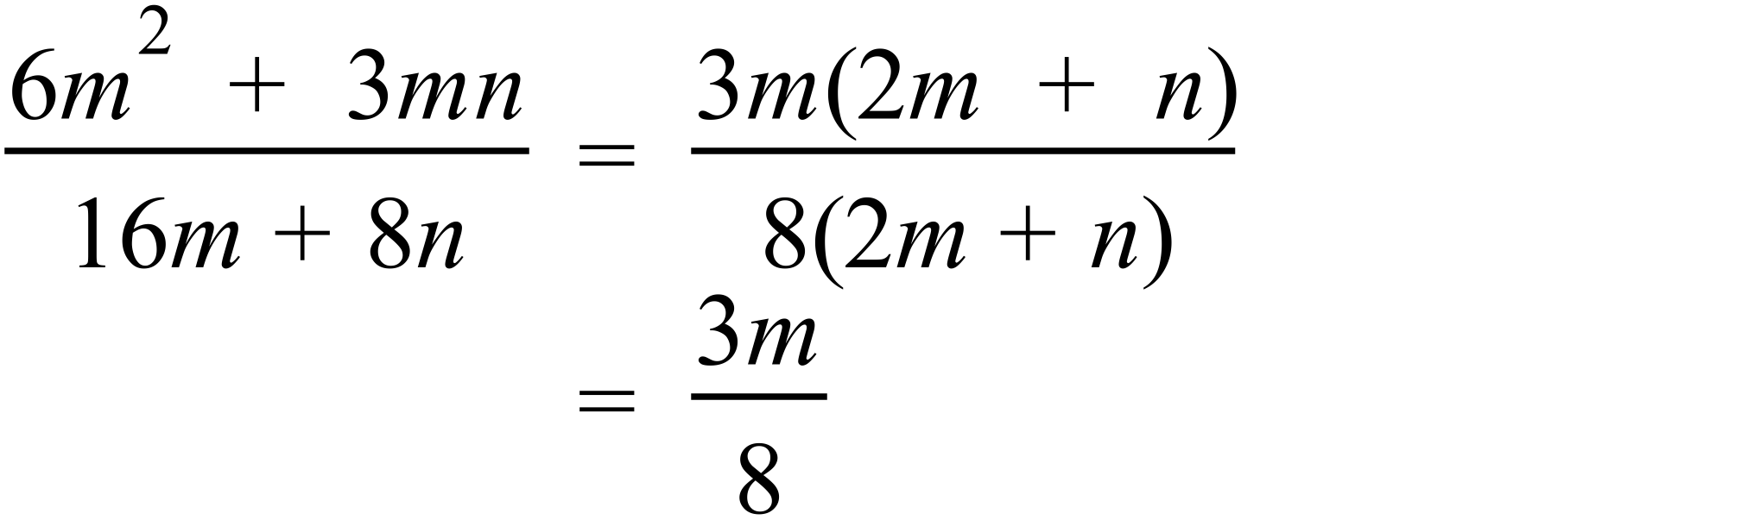 |  |  | 2 marks for correct answer  1 mark for answer with some correct factorisation or cancellation
 | (b) 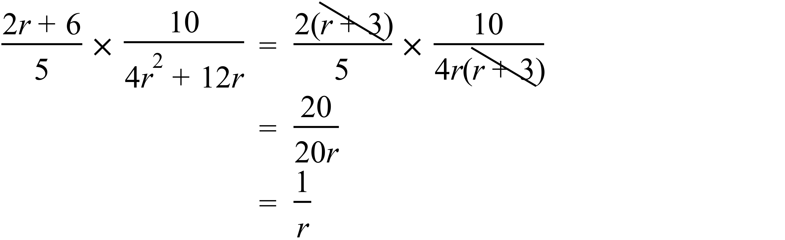 |  |  | 2 marks for correct answer  1 mark for answer with some correct factorisation or cancellation
2. | (a) 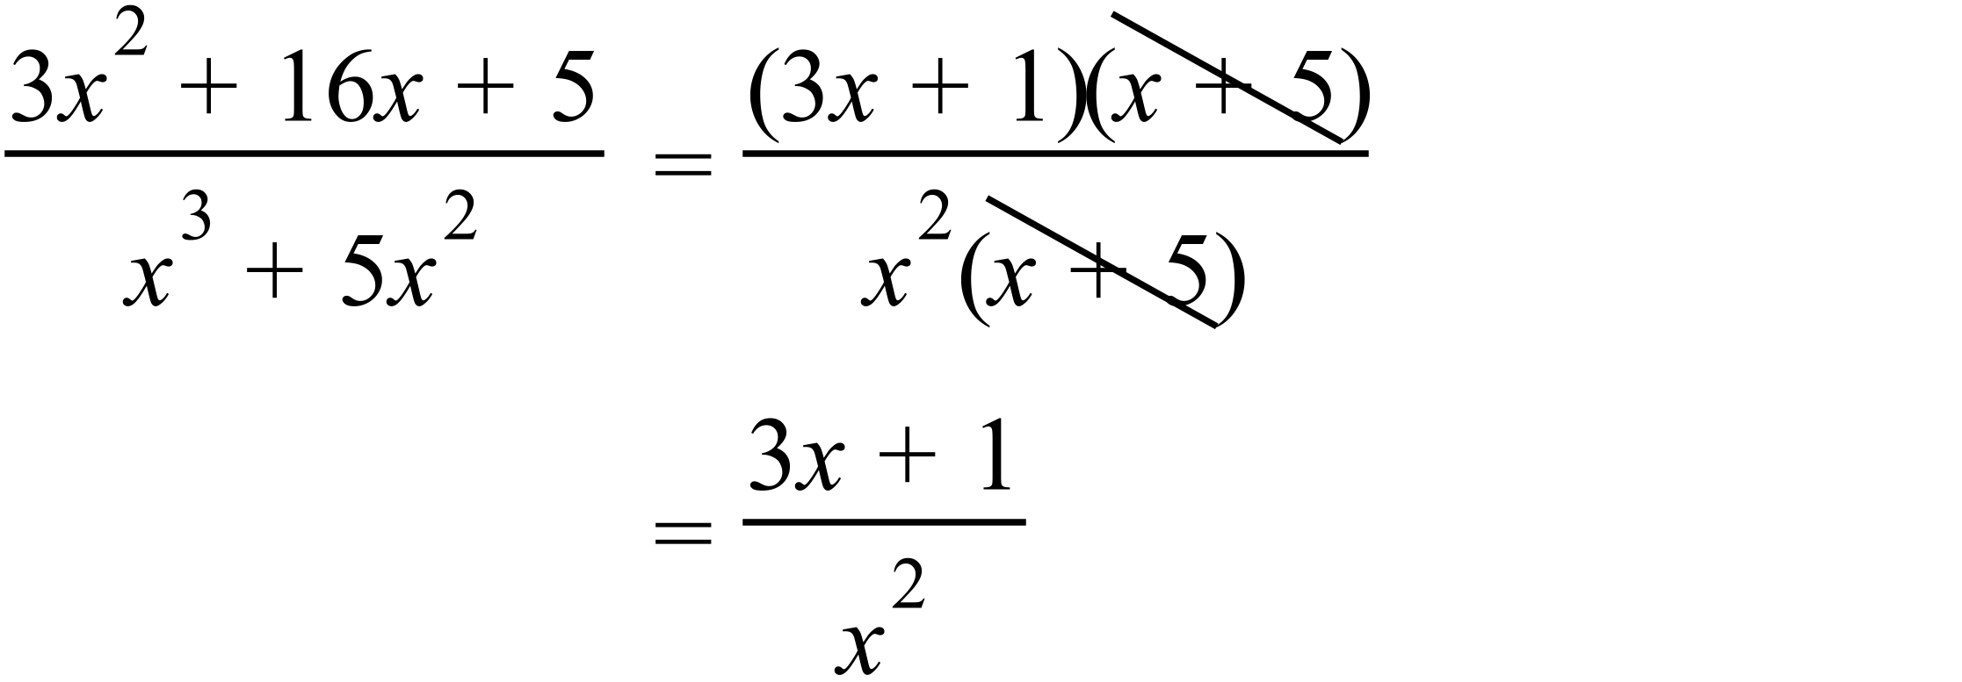 |  |  | 2 marks for correct answer  1 mark for answer with some correct factorisation or cancellation
 | (b) 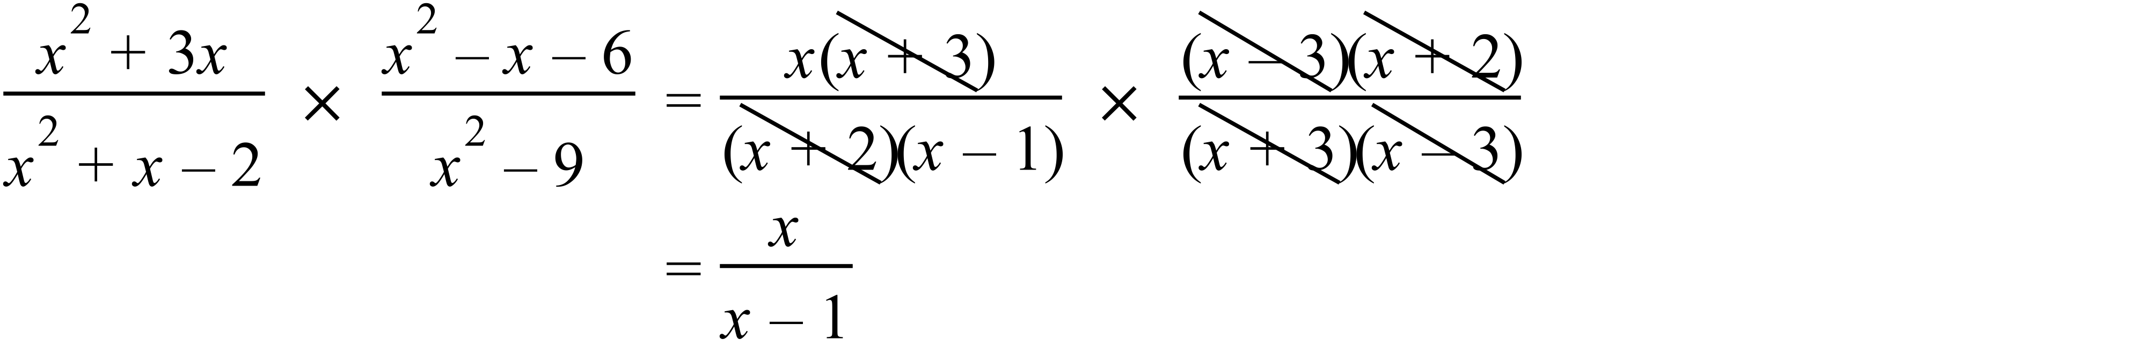 |  |  | 3 marks for correct answer  2 marks for otherwise correct answer with minor error  1 mark for answer with some correct factorisation or cancellation
 | (c)  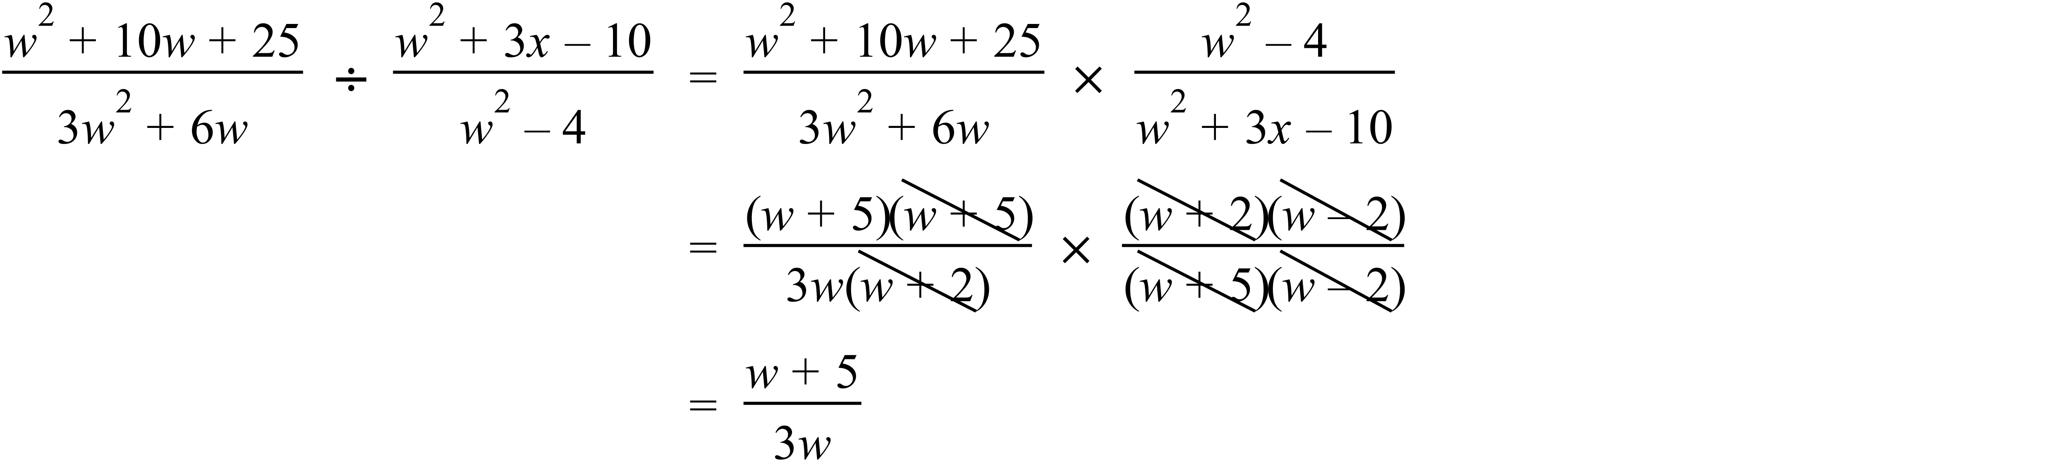 |  |  | 3 marks for correct answer  2 marks for otherwise correct answer with minor error  1 mark for answer with some correct factorisation or cancellation

